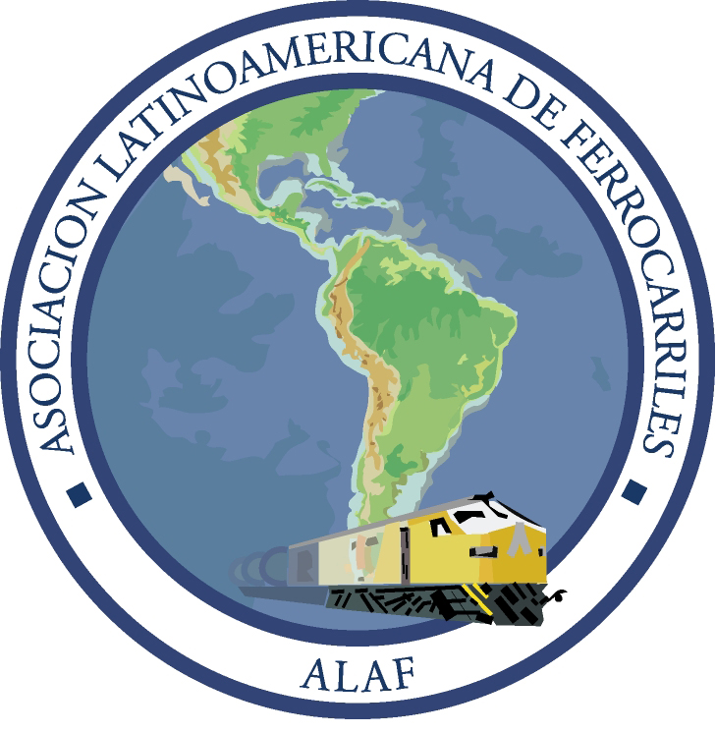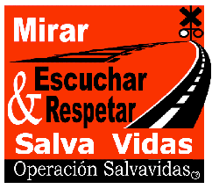

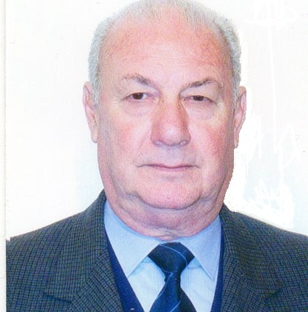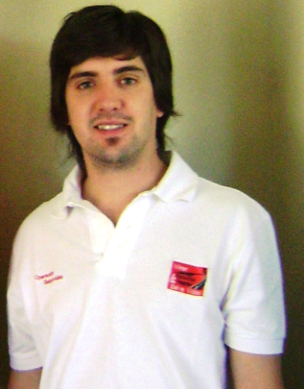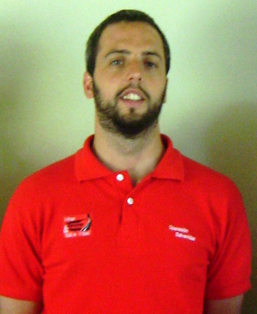
- Arnaldo Ercoli/ALAF 2)Lisandro López Piñeyro 3) Alejandro Matamalas (coordinators Operation Lifesaver Argentina)

International Level Crossing Awareness Day (ILCAD),
7 June 2012
Since 2009 the Latin American Railway Association (ALAF) has been participating actively in the International Level Crossing Awareness Day (ILCAD), coordinated by the International Union of Railways (UIC) this year on 7 June. This year we have foreseen, together with Operación Salvavidas and the Regional Faculty of Buenos Aires and the National University of Technology, to develop an ambitious program including discussions in schools, distribution of leaflets and flyers on safety at level crossings in terminal stations and at high risk level crossings, broadcast of messages on billboards in railway stations, on radios, TV, in order to aware the community as a whole on the risks that represent the non respect of existing rules and signals at level crossings.
The Regional Faculty of Buenos Aires and the National University of Technology organise on the same day a seminar on “Safety and prevention at level crossings” with speeches of well known professionals on important topics. This seminar includes a video-conference pre-recorded between Argentina and the UIC HQ with the ILCAD Coordinator, Isabelle Fonverne, which will be broadcast in the lecture hall of the same University, Medrano 951 PB - CABA, from 9:00 a.m. in Argentina (from 2:00 p.m. French time).
We shall underline the support from various railway companies that joined this campaign financing a part of the leaflets and flyers which will be distributed to road users and pedestrians who traverse those level crossings every day, which enabled this campaign being larger and more efficient this year compared to the previous years.
In addition ONGs have been approached in order to act jointly on an issue worrying the whole community; regional banks have been contacted to get the financing of programmes and actions aiming at putting forward the message that guides us: "Act safely at level crossings".

